Sprint Report 3
  - Portfolio task 2/3/4
Unit code: EAT40005
Unit Name: Engineering Project A
Submission date: 10/06/2025

Student Name | Student Id | Statement of contribution to the report
Senupama Deshapriya | 104329709 | Senupama aided in the process of documenting by consolidating Jira board inputs, writing parts of the Sprint Review and Challenges sections, coordinating the preparation for the 3D demonstration, and helped with integration of client feedback at the team meeting. Senupama helped to validate part completions, especially in terms of the refinements to the new model's animation.
Chrishelle Anthoneyz | 104067504 | Chrishelle wrote the complete description of both the Sprint Demonstration and Sprint Review sections, including client feedback comments, and the technical write-ups for the new moisture and gas flow diagrams. She also completed formatting and describing the figures and informally organized section outcomes from discussions during the retrospective meetings.
Haritha Perera | 104207449 | Haritha led the modelling enhancements, however in parallel, took screenshots and captured animations for the report. He contributed to the Retrospective and Action Items sections, with particular focus on technical solutions to the SolidWorks export and the fallback tools. Haritha helped to keep milestones on track and identified gaps in the mobile app integration with the 3D elements.
Thenura Kuruppuarachchi | 103512993 | Thenura actively contributed to creating the new moisture and gas flow diagrams. He supported reflective analysis and contributed several important reflections in the Retrospective meeting. He contributed to writing the Challenges and Resolutions section and made structural adjustments to facilitate the planning and incorporation of mobile app integration outlined in the action plan.

Acknowledgment of Country
Each team member identifies the Traditional Owners of the land they lived on while completing this work.
- Senupama Damdini Deshapriya acknowledges the Wurundjeri Woi Wurrung people as the Traditional Owners of the land they lived on while completing this work in Melbourne, Victoria.
- Chrishelle Anthoneyz acknowledges the Wurundjeri Woi Wurrung people as the Traditional Owners of the land they lived on while completing this work in Melbourne, Victoria.
- Haritha Manuja Perera acknowledges the Wurundjeri Woi Wurrung people as the Traditional Owners of the land they lived on while completing this work in Melbourne, Victoria.
- Thenura Dulnath Kuruppuarachchi acknowledges the Wurundjeri Woi Wurrung people as the Traditional Owners of the land they lived on while completing this work in Melbourne, Victoria.

SPrint plan
For Sprint 3, our team focused on completing the animation and structural refinements of the LIDA composting system and preparing for final presentation and submission. The sprint aimed to visualise the full waste lifecycle inside the composter, animate fluid and gas flow through the piping system, and ensure the 3D model was polished and ready for mobile integration. Additionally, we worked towards generating a clear and compact demonstration video for stakeholder engagement.
The Sprint 3 backlog was developed in Jira, consisting of eight key user stories focused on final animation, sensor visualization, water tank functionality, demonstration preparation, and testing. These were broken down into subtasks distributed evenly among the team.
As per unit expectations, each team member was expected to contribute 10–12 hours per week, resulting in 30–36 hours over the 3-week sprint. This brings the total estimated workload for Sprint 3 to approximately 120–144 hours for the entire team. Work estimates and assignments were recorded in Jira and tracked.

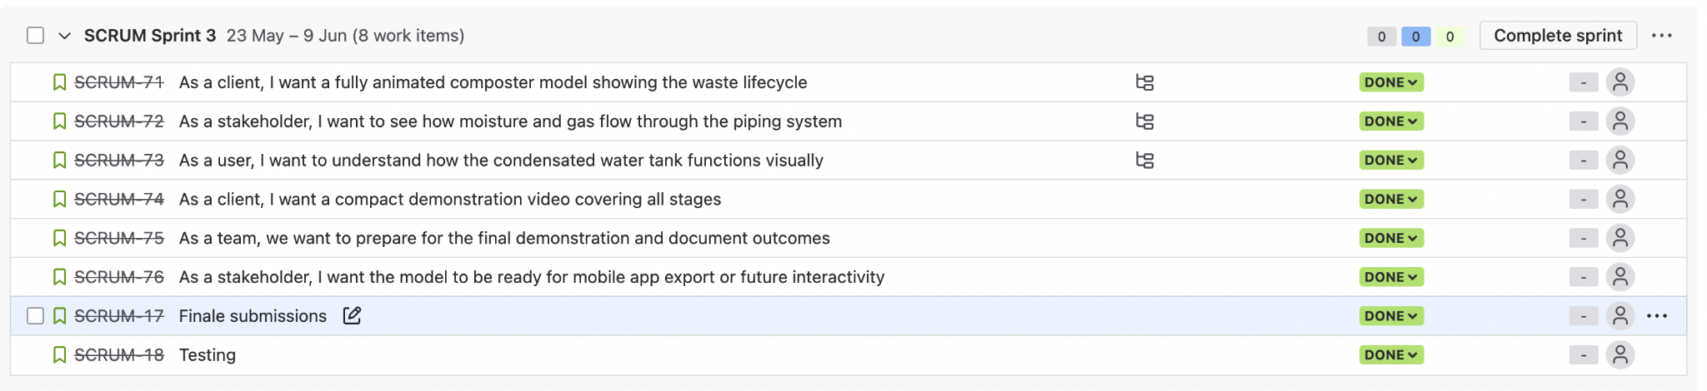
Fig 1. Backlog of user stories
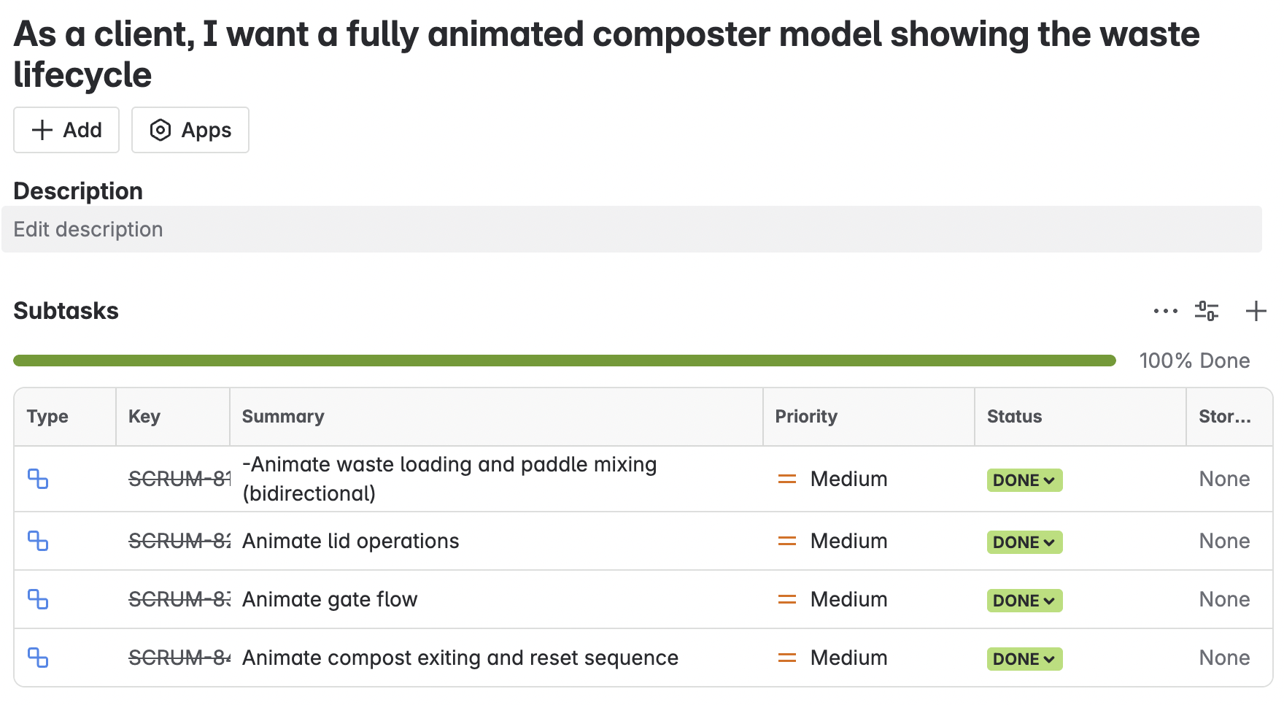
Fig2. subtasks related to user story 1
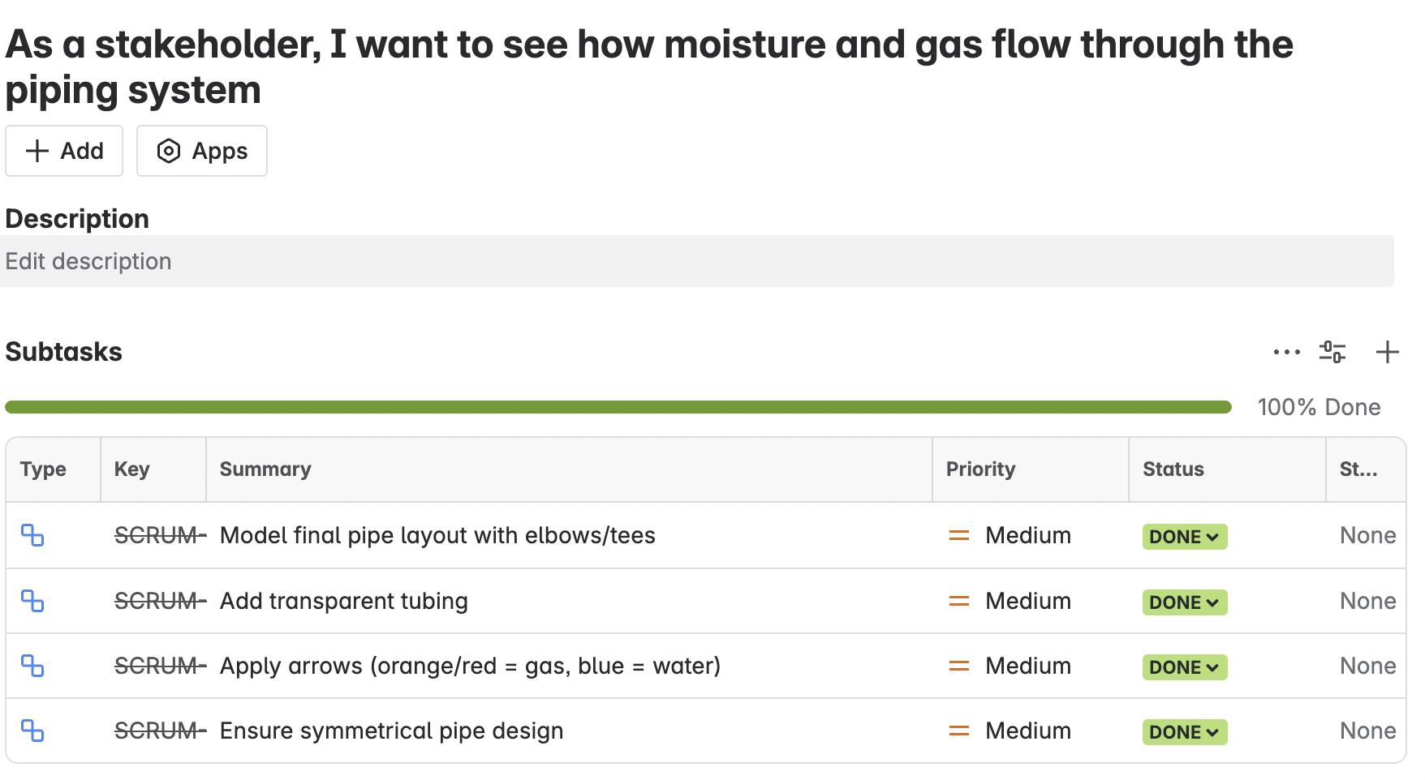
Fig3. subtasks related to user story 2
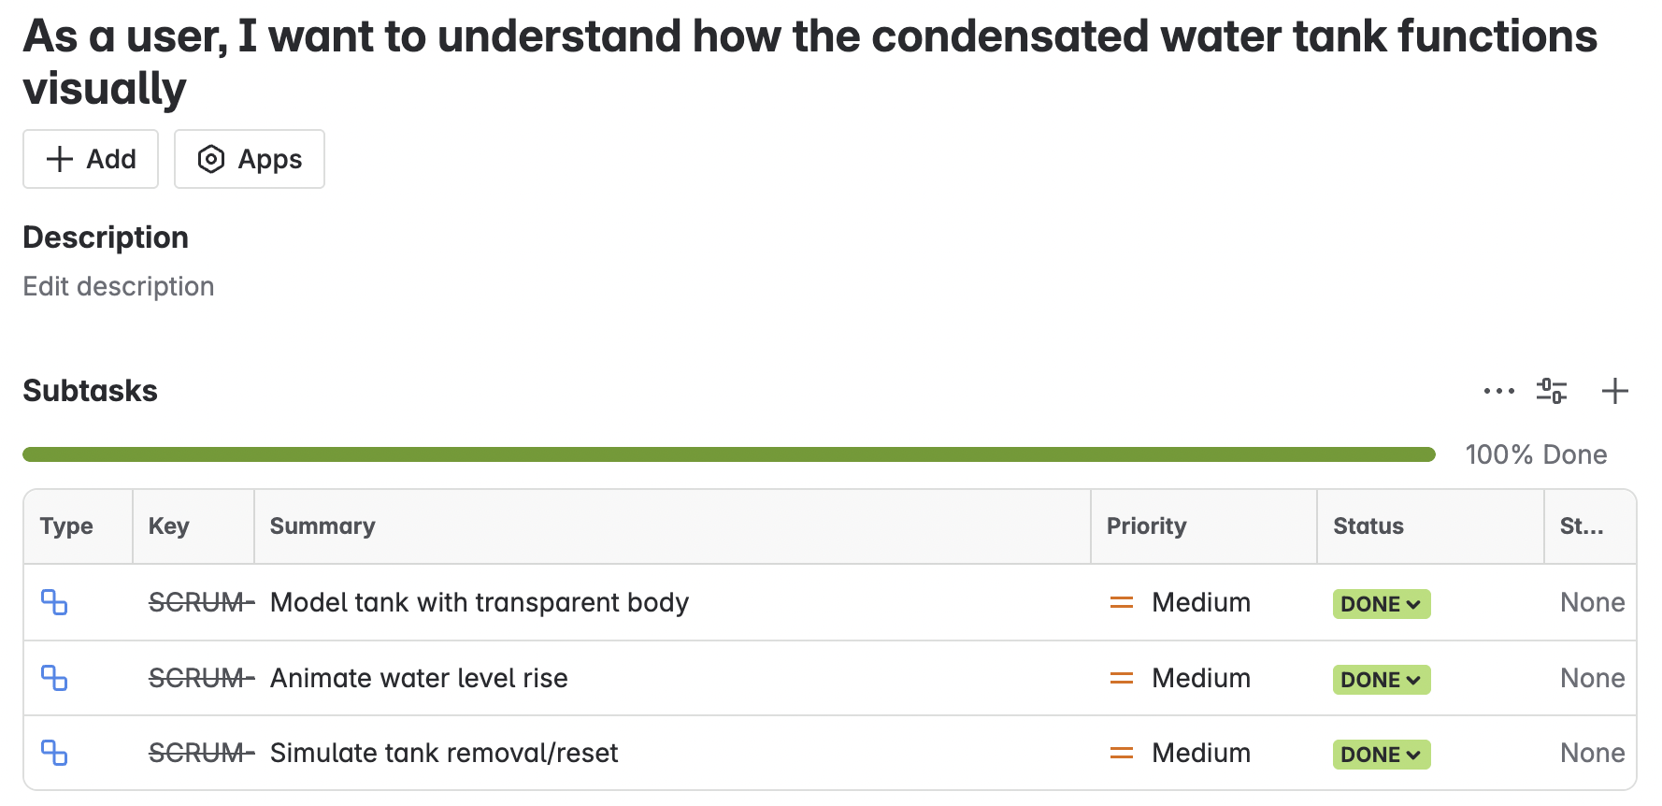
Fig 4. subtasks related to user story 3

SPrint progress
The team made consistent progress throughout Sprint 3, which ran from 23rd May to 9th June 2025, with a primary focus on completing final animations, refining the 3D model, and preparing for mobile app export compatibility. Tasks were tracked and managed through the Jira board, with progress clearly documented using the task board and burndown chart.
Initially, the sprint began with a manageable backlog of work items, which increased after feedback from the client introduced additional tasks, primarily enhancements to the pipe flow animations and refinements to animation logic. This change is evident in the Sprint 3 burndown chart, where a sharp rise in issue count occurred around May 27, reflecting scope expansion due to evolving requirements.
Despite the additional workload, the team effectively coordinated efforts to complete all assigned tasks. Task distribution was fair and aligned to members’ areas of focus. For instance:
- Senupama helped finalise animation syncing, updated Jira with task completion details, and validated model refinements.
- Chrishelle took the lead in completing the gas and moisture flow diagrams and updating the final slide decks.
- Haritha was instrumental in preparing animation exports, rendering the 3D walkthrough, and assisting with app integration checks.
- Thenura coordinated the SketchUp-to-SolidWorks modifications and proposed the water tank visual simulation strategy based on client input.
The team worked collaboratively to reflect all feedback, incorporating:
- Moisture condensation logic through directional animation arrows.
- Paddle counter-rotation refinements.
- Distinct gas and water flow representations using red and blue arrows.
- A revised pipe and chamber layout based on SketchUp dimensions.
- Testing and partial validation of mobile app compatibility.
The Jira burndown chart below clearly illustrates the task flow, with issues peaking mid-sprint and gradually reducing as team members resolved work items.
This steady progress during Sprint 3 indicates the team’s adaptability, attention to client needs, and technical growth in managing design integration, animation workflows, and preparation for mobile deployment.

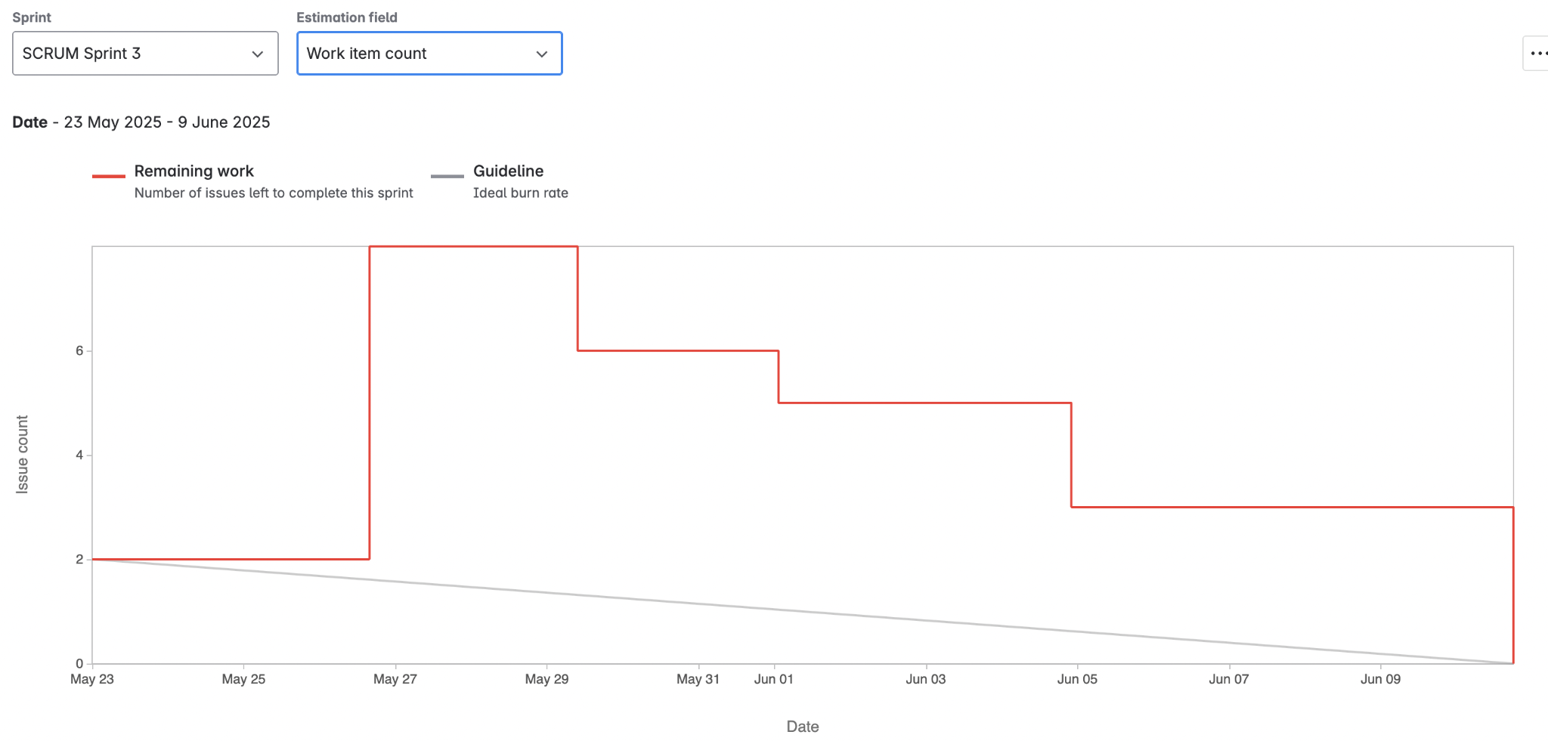
Fig 5. Sprint burndown chart for sprint 3

Sprint Demonstration
The demonstration for Sprint 3 was held on Friday 6 June 2025, from 4:30 PM to 6:00 PM in room AD324 at Swinburne University of Technology. Attendees included our client Mr. Alex Jaimes Castillo, members from the hardware teams and our software development team.
The intention of this demonstration was to show the final iterations of the animations, internal piping design, and the revised 3D model prepared for exporting into the mobile app. In this sprint we furthered animations to show simulating gas and moisture flow paths, internal paddle logic, condensation logic and an updated model from SketchUp to SolidWorks. The presentation included multiple enhancements for layer-based environmentally responsive functionality for sensor-based response areas to temperature differences inside the composting chambers.
- Dual Flow Animation (Gas and Moisture):
We introduced distinct components of gas and moisture flow ultimately using red and blue arrows. Gas (red arrows) was represented as exiting all four chambers and venting through the upper (exhaust) port, while moisture (blue arrows) accumulated, and after a time went up and out. The emphasis of the animation being that all of the moisture does not leave right away, because the moisture is warmer than the outside air, some of the moisture stays inside, condenses, and evaporates later - this was conveyed by the client.
- Water Tank and Pipe Connection:
We exhibited the water tank holding water from the side of the composter with new pipes then simulated the path of condensed water being drained.Further arrow flows (animations) were added to animate water drain direction, airflow paths, and tubing connections. These changes are in line with feedback from past reviews that indicated needing to accurately visualize environmental controls.
- Paddle Motion Refinement:
Paddle animations were adjusted to sync with motor input so they animate opposite directional rotations when moving between chambers. This change better imitates the compost mixing process, including the actuator's position on the chamber walls.
- Model Prepared for App
A representative 3D model was built using aspects of the client’s Sketchup version, along with measurements and visual clues. Structural dimensions were modified to be more realistic, while internal paddle positions and motor case were changed accordingly. The updated SolidWOrks Model was exported and set up for use in the mobile application. Textures, colour coding, and labels were completed to match the application format of phase by phase tracking of compost.
Following the Sprint 3 demonstration for the newly integrated animations, internal mechanisms and mobile-app-ready model, the client also provided constructive feedback regarding the entire demonstration. The feedback received was positive, constructive, and consistent with the potential adjustments designed to alter presentation. Listed below are key points made from the discussion.
Positive Observations:
- Distinct differentiation between gas (red) and moisture (blue) flow logic with directional arrows
- The new water tank and pipe system was successfully simulated indicating the moisture drainage and condensation path.
- Paddle animations showed the direction of movement was correct, it demonstrated counter-rotation movement and was much improved in terms of representing reality.
- The SKP-based 3D structure had a visually-dry, correctly-scaled rendering for development.
- The 3D model for mobile app integration had a visually clean look and was labelled clearly.
Recommendations for Future Development:
- Moisture Condensation Logic: The client reiterated that not all moisture escapes at once, that some of the moisture condenses, based on temperature conditions. This would be made much clearer in including arrows to indicate the upward direction of re-evaporation flow.
- Visual Differentiation: The client suggested that the compost should change the darker colours (i.e. Brown) to signify compost maturity, and to make credible dimension distinctions towards the upper phases.
- Animation Realism: The client suggested modifying the timing of the animations to demonstrate the process timings on the lids and mixing paddles for a more realistic representation and timing (i.e. delay of ~2 seconds).
- Material Representation: The client suggested that some of the placeholder compost blocks can be made and more "organic" in texture and colour, less geometric shapes.
- Structural Additions: The client suggested that additional pipe outlets to include for water drainage and gas exhaust should also be highlighted in visual representation.
Therefore, it is clear from the Sprint 3 experience that real tangible improvements have been made to the visual modelling and logical modelling of the LIDA-composting system. The 3D structure with the improvements are in line with client suggestions and there were recurrence of suggestions made. That was useful to create a clear map towards final improvements and eventual app deployment in the next sprint.

Sprint review (Critical review of the product)
Sprint 3 Demo Overview of presented demonstration
The Sprint 3 demonstration completed an ongoing progression in project design logic and component integration. The Sprint 3 demonstration emphasized realism as a continued development of the implementation of air and moisture flow logic, paddle synchronization, and additional SketchUp 3D modelling as preparation for the LIDA app. As an ongoing facilitation of review, there was the introduction of a side mounted water tank and a pair of ventilation pipes to depict a more realistic gas exhaust and moisture drainage system. Much of the demo also reviewed paddle movement as it has been completed with counter-rotating shafts to depict a realistic compost mix, and directional flow arrows which identified moisture (blue) and gas (red) pollution pathways. There was also review of the animations as they had been partially adjusted to the client feedback of interaction with the environment, particularly condensation from the large variation of temperature changes inside the composting unit.
Key Features Shown
- An updated pipe and valve system representing airflow and moisture flow with some new top outlet to signify the upward moisture flow.
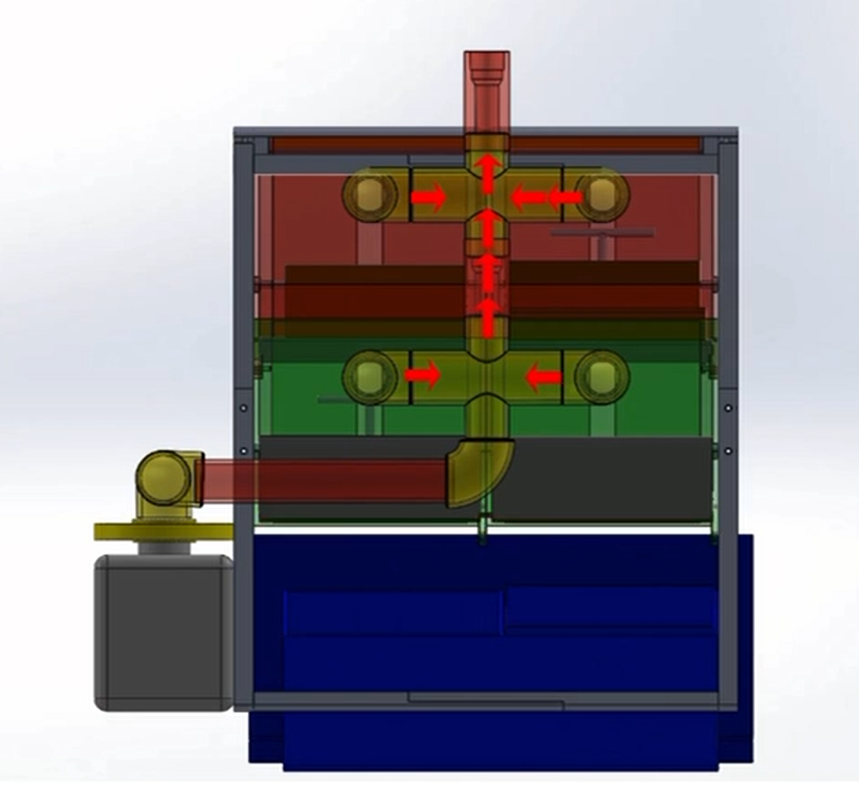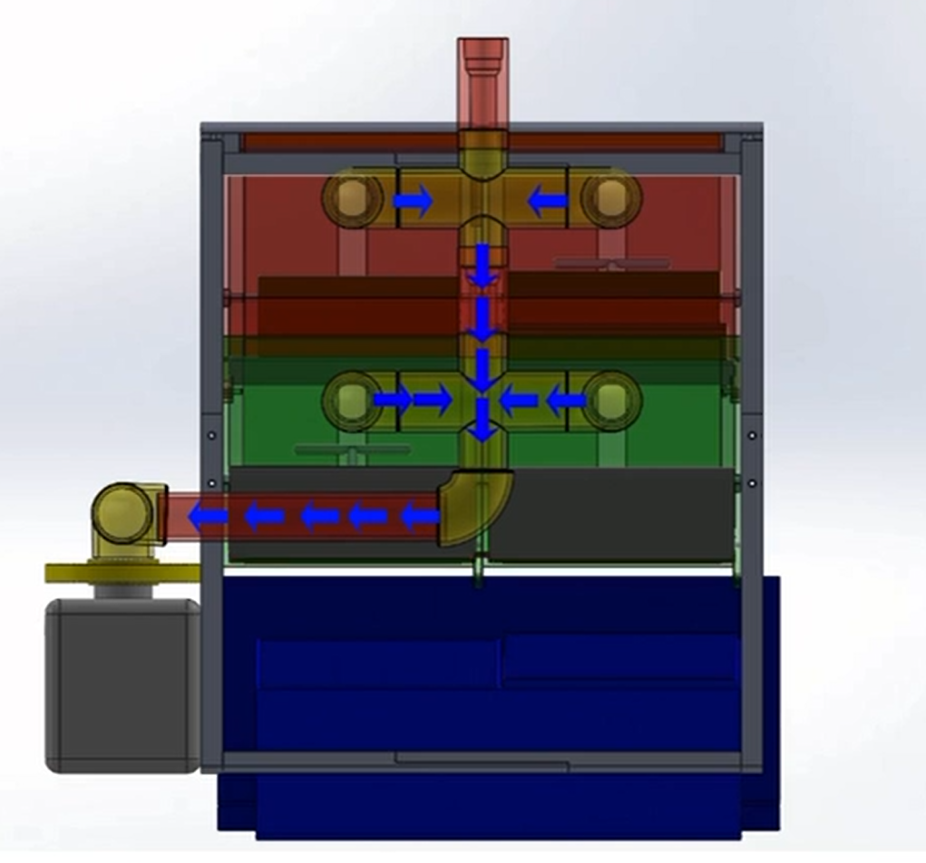
Figure 6: Cross-sectional view of the LIDA composting system showing pipe routing for moisture extraction and gas exhaust and Visualization of gas exhaust flow (CO₂, CH₄) from internal chambers to the external outlet pipe.

- Two-directional paddle animations; counter rotating paddles to demonstrate compost mixing mixing.
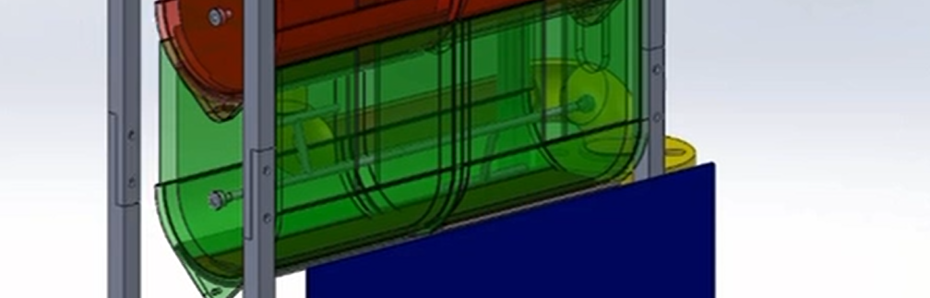
Figure 7: Internal paddle rotation system to agitate compost layers, simulating natural aerobic composting behavior.
- Water tank and an outside drainage system for separating realism of moisture.
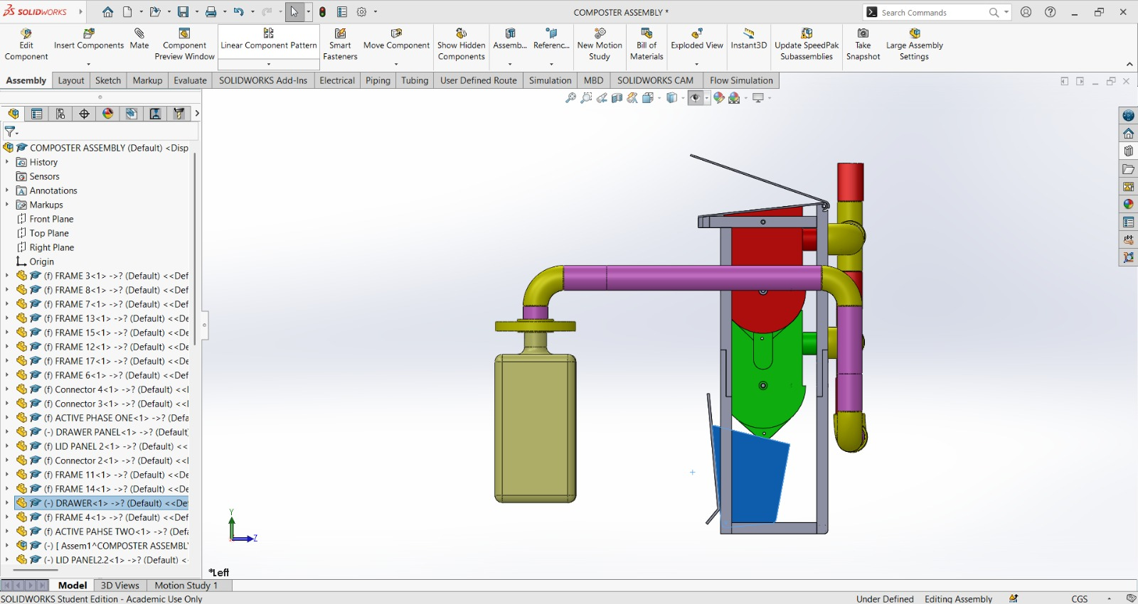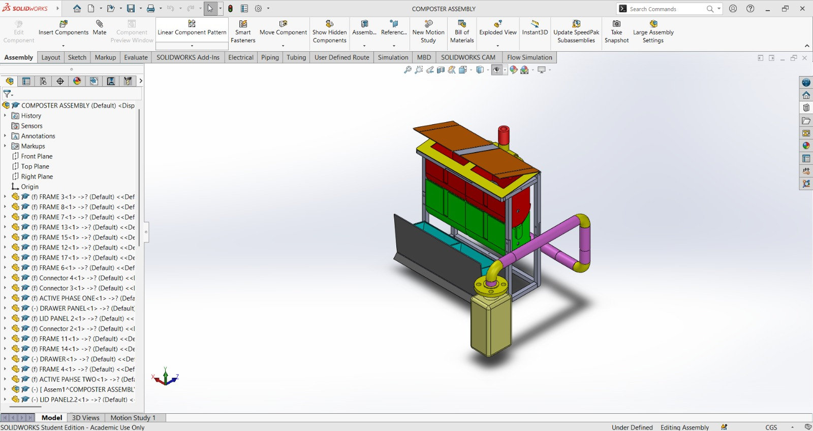
Figure 8: Integrated LIDA system with water collection tank and exhaust tubing for fluid-gas separation.

- The 3D model exported from SketchUp with the included app integrated version for animation and interactivity in the future.
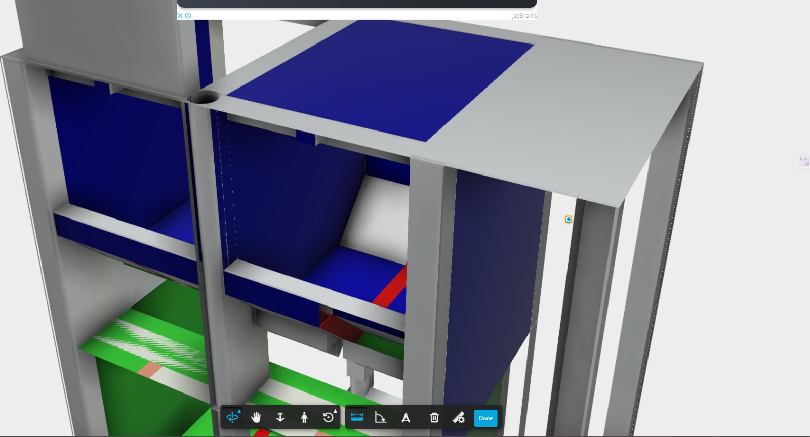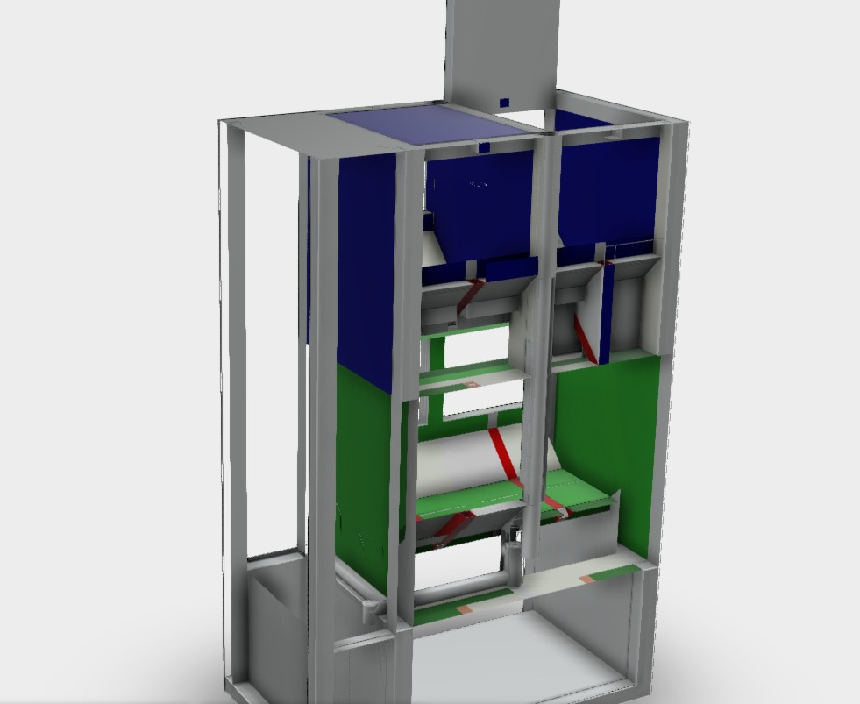
- The Piping was better, and we demonstrated how it was installed in the composter.
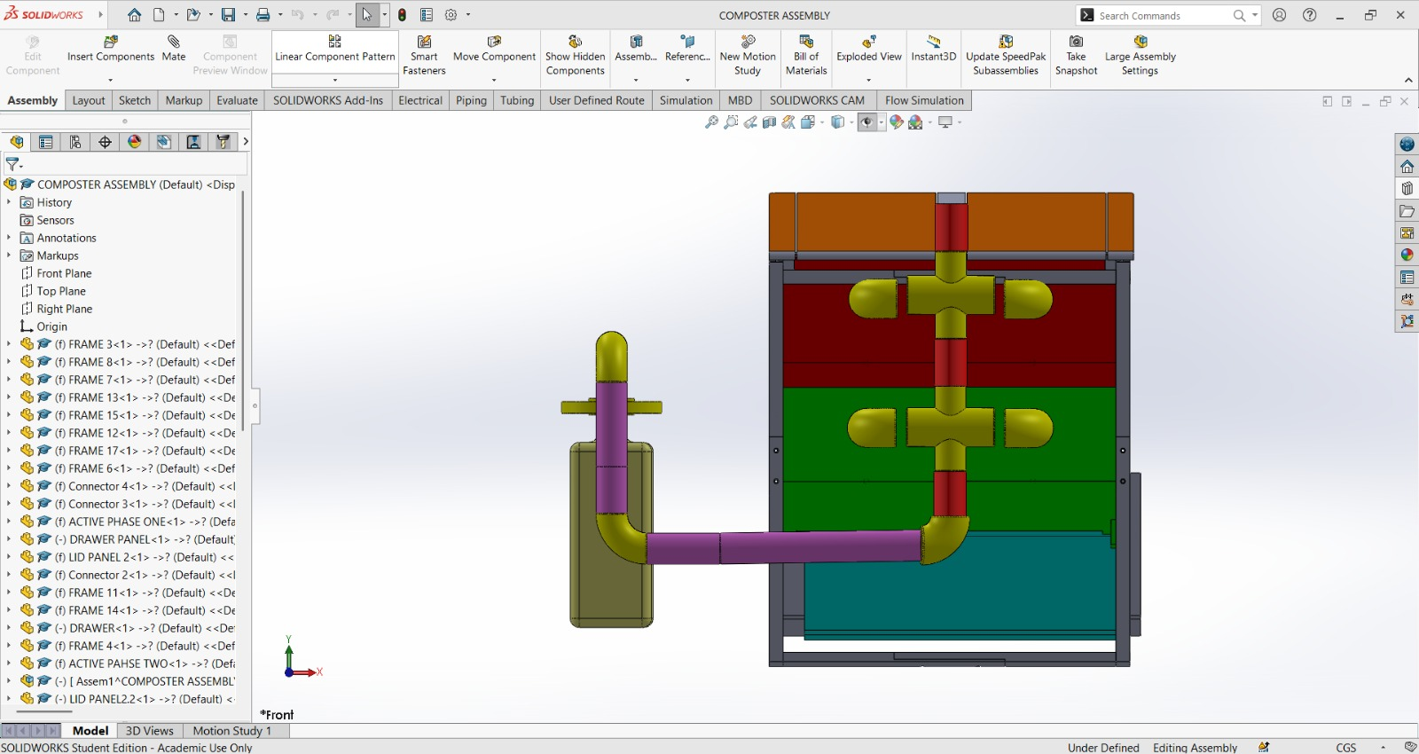
- Internal visibility is much improved; including colour-coded compost representing the composting stages: red - active, green - curing, blue - finished compost.
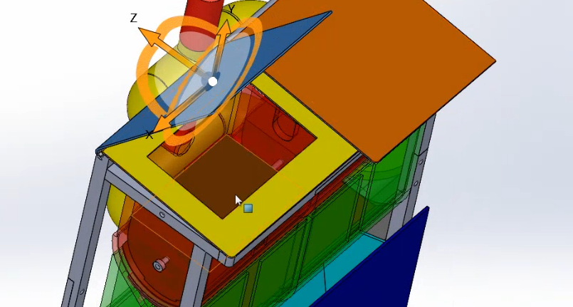
- The gas and moisture were clearly visually distinct from one another thus to better represent mental models visually for educational purposes even on a basic level.

Client Feedback
The client provided us with some excellent feedback in the review session of the refined system flow and structural changes during the Sprint 3 demonstration. Overall, the client was very happy with the system improvements recognizing that there was an increased functionality for controlling the paddles with changing the airflow logic in revised system flow but also it was coming together. Some of the key comments from the review feedback session contained and useful notes that we can use as we head into Sprint 4 are:
Positive Acknowledgment:
● Changes made to airflow and moisture logic with introduction of directional arrows help visualize how the systems will work
● The pathways lateralized for gas paths and gas paths are identified by using red and blue directional arrows respectively.
● Paddle counter rotation visually looked like it would work as expected for the compost mixing process
● The different phases (Active: red, curing: green, final: blue) were indicated by colors to help understand what phase each chamber represented.
Opportunities for Development:
● Change the top lid to stay at the same thickness of insulation but have the outer part remain flat - this will allow for a user friendly experience and increase equalization accuracy.
● Add water draining/condensation behavior based on inside-outside temperature difference.
● Add app triggered animation states on switch when actuator is started or turns off when thresholds are too low.
● Instead of the placeholder compost blocks add dynamic organic matter textures for the decaying process and increase realism.
● Add biblical methods in SketchUp for tubes and motors to illustrate mechanical working conditions.
Progress Assessment and Reflection
Sprint 3 indicated a significant step forward in the sophistication of the model, and the animation system's alignment with practical composting logic. The team had dealt with some significant design bottlenecks encountered in the previous sprint and achieved the following developments:
- Developed multiple, separate airflow and moisture path models with arrows, colour denotation, and direction logic.
- Designed revised visual materials with brown shading showing compost layer and food waste flows.
- Changed the chamber sizes and locations of the SketchUp file with the most recent dimensions identified and streamlining visual representation with performance.
- Validated early mobile application integration and reduced rendered model size and number of layered surfaces for improved render time.
- Confirmed connectivity between SolidWorks and Unity3D to also ensure export to simulation compatibility.
Challenges and resolutions
Challenge | Description | Resolution
Model Overhaul & Size | The newer model using SketchUp was just too complicated and the dimensions were different | Dimensions set, flattened the model, removed unnecessary parts, made easy for unity/mobile.
Visual Simulation Delay | The paddle, gas, and moisture flows need a new logic this still does not allot for enough time to animate, | Distribute tasks through into subtasks: some completed in Sprint 3; the other not started until Sprint 4.
Arrow Direction Logic | The arrows only illustrated outward flow, they did not how condensation would behave. | Blue arrows are now revised to flow straight upwards; changes have been made to the animation logic.
This review cycle showcased the flexibility and problem-solving skills of the team. While there were animation delays and mobile application export testing to overcome, the visual design logic now supported real composting flows, and the context of interfaces with mobile platforms were developing solid. During this review cycle, it was evident form the quality of actioning of issues within team meetings that the team had developed significantly in terms of handling technical complexity, and coordinates an interface with real time hardware assumptions.

Retrospect (Critical review of the process)
Overview
After Sprint 3, a retrospective meeting was held online using MS Teams on Sunday 08th June 2025, from 11:00am. to 1:00p.m. The meeting reflected on the collaborative workflow, technical gains and planning challenges of the second sprint while also looking ahead to the final sprint. Discussion included what valued our practice, what challenges we experienced and how we could improve coordination and animation delivery for sprint three.
Meeting Details
Date | 8th June 2025 (Saturday)
Time and Venue | 5:30 PM
Attendees | Chrishelle Anthoneyz, Haritha Perera, Thenura Kuruppuarachchi, Senupama Deshapriya
Retrospective
Start Doing | Stop Doing | Keep Doing
Validating animation logic before fully rendering (especially airflow paths) | Waiting to test flow directions until after the demo | Having weekly check-in calls in a structured way
Exporting and testing .GLB files early in the sprint | Assuming exported models from previous sprints will still work | Frequent client and hardware team feedback syncs
Visualizing pipe flow using dual arrows (gas in red, moisture in blue) | Overloading what is possible in one sprint with the combined app + animation features | Using the Jira board to manage what and who was doing what
Verifying components layout with the alignment of the SketchUp model | Using just one tool (SolidWorks) to do all model validations | Using the SketchUp model for dimensional accuracy
Creating versions for mobile in parallel | Deferring testing of fallback tools until sprint completed | Utilizing fallback tools (e.g., Blender, Fusion 360) when needed
Action Items for Upcoming Sprints
- Start the process of creating the LIDA mobile app, focussing on substantial features such that it displays real time sensor data, contains actuator control buttons, and includes system status indicators.
- Import the exported .GLB model of the composter into the Lap Mobile app using any of the possible 3D libraries like (Unity3D, or Babylon.js, or Flutter 3D packages.)
- Create the animation logic that will be triggered by the sensors, to have an animation that reacts visually when there are inputs that confirm temperature thresholds or gas build up.
- Create manual override functions in the app for lid control, paddle activation, and air pump toggle.
- Create the user interface design and build with an accessibility and simplicity approach, and ensure essential points for controls and data are the focus.
- Conduct app-side testing for QR code pairing and identification of devices that simulate a connection to the composter hardware.
- Include colour-coded labels on the chamber, animated flow arrows, and the feedback overlay to provide user context into the compost stages.
- Complete cross-platform compatibility for Android and iOS devices, flexible enough for adaptive design.
- Document all of the interaction flows, the navigation wireframes, and usability testing results for user verification in the final stage.
- Lift the collaboration with the hardware teams to create a syncing protocol to determine that recommended actuator states were indeed caused by the app control triggers.

Lessons learned (Critical review of SPRINT three experience and future plan)

1. Layered Animation Enhances Clarity
One major learning from Sprint 2 was that combining all motions into one large animation file led to confusion and performance issues. In Sprint 3, we learned to separate animations by function and stage (e.g., waste movement, lid opening, condensation), which allowed for easier debugging, clearer logic mapping, and more modular exports. This significantly improved both animation precision and usability across platforms.

2. Export Optimization Is Essential for App Integration
When preparing the model for mobile export, we realized that even minor excess geometry (e.g., hidden chambers, internal mechanisms) created lag or glitches in the app preview. Lessons from Sprint 2 helped us reduce mesh complexity. In Sprint 3, we actively removed hidden bodies, simplified assemblies, and pre-rendered sequences when animation interactivity was not essential, improving performance on lower-end devices.

3. App Feedback Loop Must Begin Early
While Sprint 2 focused on perfecting animations within SolidWorks, Sprint 3 showed that waiting until the final stages to consider app testing limited flexibility. Minor visual bugs in the app version appeared late, and testing rounds were rushed. This highlighted the importance of parallel testing during animation creation rather than after exporting.

4. Separation of Visual and Logic Layers Improves Scalability
In Sprint 3, we realized animations needed to be split from the control logic (e.g., motor triggers, airflow animation). Feedback from the client emphasized the future integration of real-time data to trigger animations. By isolating visual sequences from mechanical logic, we laid the groundwork for scalable, data-driven interactivity next semester.

5. Demonstration Narrative Must Guide Structure
The need to produce a polished 1-minute demo video for the final presentation pushed the team to rethink how the composting process is communicated. Sprint 3 taught us that animations must follow a clear narrative, not just technical accuracy. This meant adjusting speeds, angles, and transitions to be more intuitive and educational.

6. Feature Prioritization Is Crucial Under Time Pressure
Sprint 3 had overlapping tasks (sensor logic, app export testing, model finalization), which strained time management. We learned to prioritize essential deliverables over optional features and cut or defer non-critical tasks (e.g., advanced air-flow toggling, live animation triggers). This helped ensure we met deadlines without compromising quality.

Practical and Feasible Future Suggestions
Area | Recommendation | How it will be implemented
Animation Segmentation | Separate animations by function/stage | Assign distinct layers in SolidWorks for export clarity
App Preview Integration | Test exported model weekly in mobile preview | Conduct iterative testing with low-res exports during modeling
Export Efficiency | Remove non-visible parts and hidden geometry | Export only visible assemblies and suppress heavy components
Interactivity Planning | Isolate animation from logic triggers | Use separate scripts and labels for visual playback and logic events
Demo Video Design | Build animations around storyboards | Follow a storyboard and sync narration/timing during editing
Task Scope Management | Defer non-essential tasks when load is high | Use weekly planning boards and flag tasks that can be pushed to Semester 2

Future Plans for next Semester:
- Build logic-based triggers for mobile animation syncing.
- Finalize lightweight, app-ready model exports with annotations.
- Conduct user walkthroughs of the 3D model within the app interface.
- Explore potential for real-time data integration with app triggers.

Appendices
Project Decompose
https://github.com/Thenuradulnath/Mobile-app-design-and-automation-of-hardware-assemble-for-decomposing-prototype
https://student-team-eat40005-mobileappdesign.atlassian.net/jira/software/projects/SCRUM/boards/1

